PARISH NEWS
The Deverills & Crockerton
Lord’s Hill towards Longbridge Deverill
By Pat Armstrong

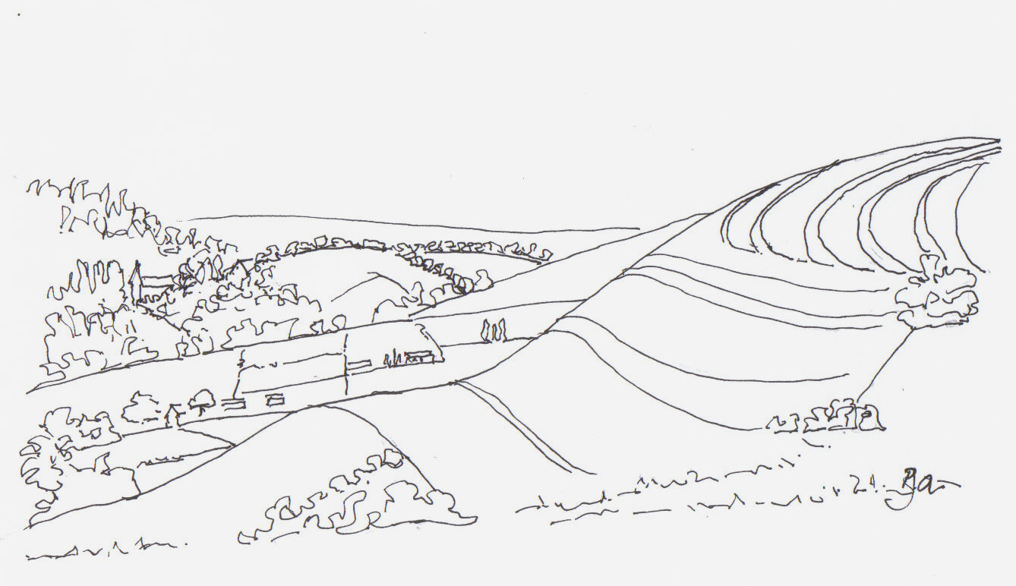

January 2009

Look inside for local information

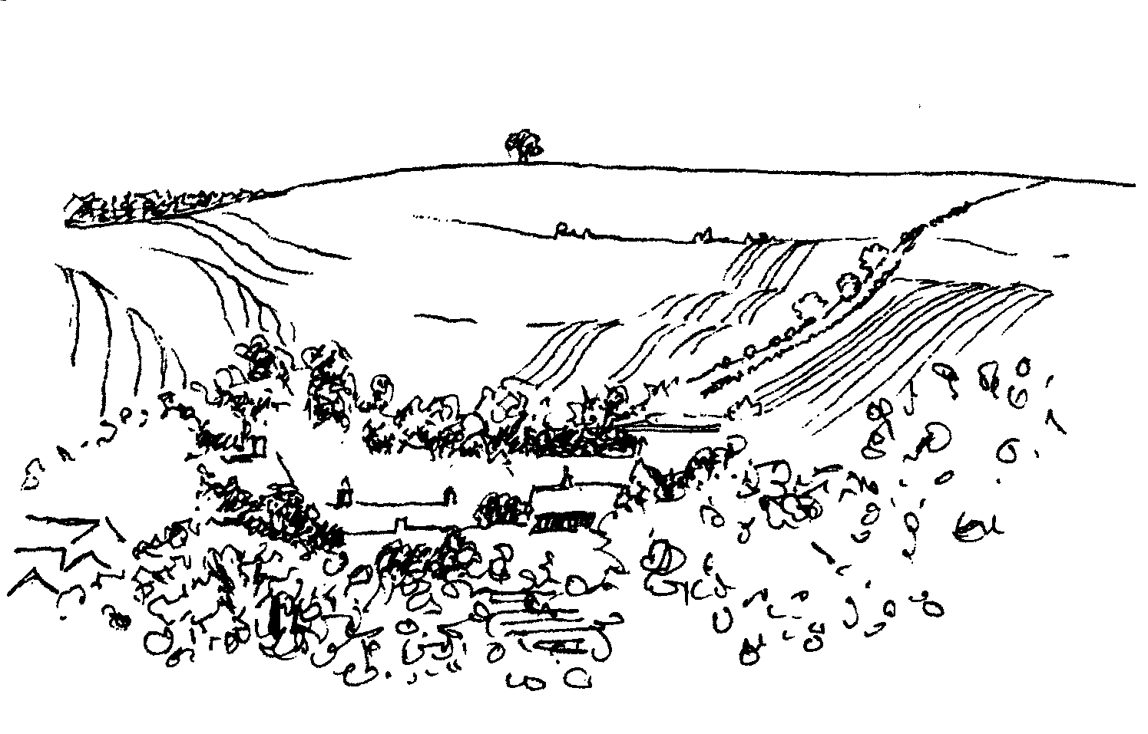
-2-

Longbridge Deverill Village Hall
HAPPY NEW YEAR
BURNS NIGHT
SATURDAY 24TH JANUARY
7.00 pm for 7.30 pm
Please book early, at least a week before the event
Tickets £10 from Sylvia Titt on 214824 or Pat Wood on 840535
Bring your own Wine

Friends of Heytesbury, Knook and Tytherington Churches
3 talks with supper held in Sutton Veny village hall in aid of the churches

Tuesday 20th January
‘Cricket, Lovely Cricket’ by Dennis Silk
Tuesday 17th February
1st Overland Oxford & Cambridge Far East Expedition 1955
by Anthony Barrington-Brown
Thursday 19th March
Conservation of Historic Buildings by John Maine

The doors open at 6.30 pm talks to begin at 7.00 pm prompt
Tickets £15.00 for a talk & supper or £40.00 for the series, please contact
Jane Howard-Vyse, 74 High Street, Heytesbury BA12 OEB (840258) or
Annie Charlesworth, 57 H Cheques payable to The Friends of HK&T Churches

Salisbury Theatre Club Trip
Monday 16th February
The Winslow Boy by Terence Rattigan
The cost is £17.00: theatre seat £12.00 and coach trip £5.00
Booking and payment in advance to Mary Stewart Cox Tel 840877
Longmead, Brixton Deverill, Warminster BA12 7EJ
Coach leaves Kingston Church 6.10 pm collects through the Deverills
Performance begins at 7.30 pm

-3-
Journeying into the New Year

New plans, new hopes, new resolve!

‘Standing at the gate of the year’ enables a look back on the year just ended and a look forward to all the New Year might bring. Are we able to learn from the past, to do things differently? Anticipating the new is like standing on a threshold of great possibilities. Highlights of the past year remain in our minds, as we wonder about what the new one has in store.
We shall all be one year older – yes – without a doubt! Holidays may be planned, special dates written in the diary. Some things we await eagerly, others we would avoid if we could.
It won’t be long before the dark days of mid-winter begin to lengthen a little. Brave shoots will rise gently above the frosty ground and remind us of the prospect of snowdrops and crocuses, of the new life of spring. Yet at the same time, we find ourselves thinking of those for whom the New Year may be filled with dread, of those living with the threat of redundancy, of those who are homeless or facing other substantial difficulties.
I offer you these words by Carol Dixon:

Step softly into your weeping world, incarnate God;
embrace it in your love.
Bring light into broken lives,
warmth into frozen hearts,
hope to those at war.
May your peace pervade every place.

Help us to approach this new year
filled with the joy of your companionship,
as we step out in faith with you,
ready to face the future,
whatever it may hold.*

A Happy New Year and God bless you all.
Norma Payne - Rector

* From Hay and Stardust edited by Ruth Burgess,
published by Wild Goose Publications / The Iona Community

-4-
Deverill Valley & Crockerton Women's Institute
Longbridge Deverill Hall
Monday 12th January 7.30 pm
A year in the life of a New Forest pony and its owner,
the commoner by Ann Sevier
Followed by a social time
For more information contact Ann Dufosee 840360
Everyone is very welcome to join us

Yoga in Crockerton
New Year classes at Bull Mill begin on 13th January:
Tuesday evening 7.00 - 8.30 pm
Wednesday morning 9.30 - 11.00 am
Thursday evening 6.30 - 8.00 pm
To book a place and for details of classes in Frome & Shaftesbury, please call Olivia and Daniel on 212 716
Beginners welcome!

Fairtrade Everyday Cookbook
This recipe is in the Cookbook, published by Dorling Kindersley, available in bookshops rrp £16.99. More than 100 mouthwatering dishes using Fairtrade ingredients, contributions by supporters, producers and celebrities.
Hot dark chocolate fondant - Serves 4
Preparation time: 5 minutes. Cooking time: 12 minutes
Ingredients
125g (4½ oz) butter, diced plus extra for greasing
150g (5½ oz) Fairtrade caster sugar, plus extra for coating the ramekins
125g (4½ oz) Fairtrade dark chocolate, chopped; 3 large eggs ; 35g (1¼ oz) plain flour
Method
Preheat the oven to 200°C/400°F/Gas Mark 6
Lightly butter four 100ml ramekins or other ovenproof dishes to a maximum size of 150ml (5fl oz) each, and coat the insides of each with 1 tsp caster sugar. Place the butter and chocolate in a bowl and set it over a pan of barely simmering water. Melt gently and set aside. Beat the remaining caster sugar and eggs together, then mix in the flour. Fold the chocolate into the egg mixture and pour into the ramekins. Bake in the oven for 10-12 minutes until risen. Serve immediately.

-5-

Upper Deverills Village Hall
Bill’s Music Evening Friday 16th January
Bill Knowles will present an eclectic mix of music starting at 7.30 pm. Bread and Cheese will be provided and those attending are asked to bring their own liquid refreshment. This annual event is designed to arrest the ‘post Christmas blues’ and provide a warm and convivial atmosphere in which to listen to an intriguing range of music. There will be something for everyone.

Film Night Friday 6th February

The film night will start at 7.30 pm. The title of the Film will be confirmed in the February edition of Parish News.

Forthcoming events for 2009
Please make a note in your diaries
Friday 16th January Bill’s Music Evening
Friday 6th February Film Night
Saturday 18th April Indian Curry Night
Friday 19th June Rounders Evening
Saturday 4th July Duck Race
Saturday 18th July Summer Fete
Friday 2nd October Film Night
Saturday 17th October Harvest Supper
Sunday 8th November (Remembrance Sunday) Curry Lunch
Friday 13th November Quiz Night
Friday 4th December Bingo
Sunday 20th December Carol Service

Upper Deverills Village Hall Kitchen
As the New Year begins we all think about New Year resolutions and projects. This year the village hall committee hope to revamp the kitchen in the village hall, which is old and worn out and in need of replacement. As the kitchen is the heart of the home, this kitchen should be the heart of our village community; a kitchen to be proud of and used for family functions, by clubs and groups and on village occasions. We would like to make this a joint mission, the village hall committee and everyone in our community. The refit will require funding and one splendid fund raising suggestion came from Carol Noonan: a Village cookery book. This is something everyone can contribute to. We envisage good easy, everyday, tasty recipes with a foot note such as: ‘This was Aunt Maud’s marvellous mince tart recipe which she used to bake for her 11 children on Sundays’. I will start collecting recipes after Christmas and let you know where to send them in the February Parish News. We have made two applications for funding to help this project, and we await the results.
If there are any kitchen fitters in the community please keep us in mind when you are stripping out kitchens. We need items such as a second hand double sink, cupboards, cooker, dish washer, etc. If you have any good ideas for raising money or items to donate to the kitchen project please contact me. I will be chasing you all in the coming weeks for recipes. Finally, has anyone got a hostess trolley they don't need any more? The village hall would like to give it a good home.
Dizzy Bridge 845166

-6-
Floods
Flash floods affected our valley on Saturday 13th December. A huge amount of water, unable to soak into the ground, flowed in torrents down the Deverill valley. Many people were affected by it, some homes were flooded but the community spirit which came out to help was wonderful. How good it is to live somewhere where people help each other. Help also came from the Fire and Rescue Service who arrived in the villages to assist in whatever way was needed. They moved belongings and furniture away from the water, brought equipment to pump out people’s homes and suck up the mud; they removed wet carpets to enable houses to dry out, and generally lent a hand wherever it was needed. All this with calm cheerfulness, good humour and kindness. It is so great to know they are available when we need them. Our grateful thanks for all their help and advice.
Judy Munro
Longbridge Deverill and Crockerton Parish Council
The Councillors wish everyone a Happy New Year and hope to see you at our next Parish Council Meeting to be held at 7.30 pm in Longbridge Deverill Village Hall on Monday 5th January. All members of the public are welcome to attend. Look out for the Agenda on the Parish notice boards and come and meet us!
Neighbourhood Watch – Kingston Deverill
Not much to report on the village policing front. Last month, my husband, PC Phil Bridge, was on a pursuit driving course learning how to throw the Stinger across the road to catch criminals. He is back to normal duties now. It will be interesting to see if the traffic speed indicators in the Deverills were effective. I can be contacted by phone or a visit is always welcome at Longbarrow, Kingston Deverill.
Dizzy Bridge 845166
Your Parish News - Donations and Subscriptions
Thank you to those who generously donated boxes of paper for printing the Parish News during the year, these really help to keep production costs down, and we would be very grateful for further donations in 2009. As usual in January we are asking for the annual subscription of at least £5 per household. Your contribution is vital to ensure the continuation of our Parish News which helps to keep our community informed of news and events within and outside our area, as well as other important information. Please use the enclosed pale blue envelope for your donation and if you are a UK tax payer complete the sections so that we can reclaim the tax. Some financial support is also received from the PCC and other Parish Organisations. Thank you. The envelopes can either be:
Put into the collection at Church or given to a Church Warden
Given or sent to David Stratton, PCC Treasurer, Manor Farm, Kingston Deverill
Put into the collecting box on the counter at Longbridge Post Office
Sent or given to Judy Munro, Whitepits Lodge, Kingston Deverill
A special thank you to all who help to produce and deliver the Parish News.
Judy Munro - Editor

-7-
Traffic Update - Closure of the A303
For those of you who are not aware the Highways Agency (HA) will be closing the A303 from 9th February for about 12 weeks (May). They are closing a 6km section in both directions between Mere and Willoughby Hedge in order to conduct essential repairs to the road surface, drains and crash barriers. The HA will put in place east and westbound diversion routes during the closure which are as follows:
Eastbound – Off at the Podimore round about then along the A37 to Shepton Mallet, A361 to Frome, then A36 and back onto the A303 at Wylye.
Westbound – Off at the A303/A350 junction then south to Shaftesbury, then B3081, via Gillingham, back onto the A303.
As you can see the diversions, particularly eastbound, add considerable mileage and are likely to encourage drivers to find alternative short cuts. Unfortunately one of the shortest routes around the closed section of the A303 is the B3095 to A350 (at Longbridge) back to A303, or conversely the B3095 to Monkton, then the Hindon Road onto the A350 and back to the A303. Both these routes can be used in either direction to avoid the closure.
The HA are going to considerable lengths to clearly mark the diversion routes and are giving drivers plenty of early warning; for example eastbound traffic is being warned as far back as Exeter. In addition the HA are imposing a temporary 7.5t weight restriction on the B3095 during the closure. All this will undoubtedly help to discourage drivers from using the B3095 and associated routes. However, for those drivers using satnav the B3095 etc represent attractive alternatives to the official diversions. In view of this the UDPC Traffic Advisory Group (TAG) has approached InterRoute, the company commissioned by the HA to conduct the work on the A303, to determine whether they can introduce further restrictions should the traffic flow on the A350, B3095 or Hindon Road increase dramatically during the closure of the A303. The TAG has suggested that they consider erecting ‘Road Closed, Access Only’ signs at both ends of the A3095 and at the Hindon Road/A350 junction. Ideally signs warning drivers of these additional restrictions would have to be erected at the beginning of the official HA diversion routes. Another possible measure might be to physically close roads, however this should be considered as a last resort.
The closure of the A303 and the associated impact this will have on increased traffic flow through the Deverill Valley and on the A350 should not be under estimated (for the B3095 a worst case scenario would see a tenfold increase in traffic). In light of this there was a proposal to hold a public meeting to which InterRoute would be invited to address our concerns. However, as a result of the recent public consultation exercise conducted by InterRoute, and the large number of adverse comments they received concerning their plan, InterRoute are now reviewing the programme of work in order to try and further reduce the inconvenience to road users and the general public. Once details of their revised plan are known we will be in a position to determine whether there is still merit in calling a public meeting, to which InterRoute would be invited. Contact Ranald Blue on 01980 615949 (W), or 01985 841374 (H) or via email: Ranald.Blue176@mod.uk

-8-
SERVICES PARISH OF DEVERILLS & HORNINGSHAM

Sunday Epiphany
4th January Brixton 8.00 am Holy Communion 1662

Longbridge 10.30 am Morning Worship

Horningsham 5.30 pm Holy Communion

Sunday Baptism of Christ
11th January Kingston 10.30 am Holy Communion

Horningsham 6.30 pm Plough Sunday

Sunday Epiphany 2
18th January Longbridge 8.00 am Holy Communion 1662

Horningsham 10.00 am Christian Unity Week of Prayer
Chapel

Brixton 10.30 am Holy Communion

Sunday Conversion of St Paul
25th January Longbridge 10.30 am Holy Communion

Horningsham 11.15 am Morning Prayer

Kingston 6.00 pm Evening Prayer

Sunday Presentation of Christ
1st February Kingston 8.00 am Holy Communion 1662
Longbridge 10.30 am Morning Worship
Horningsham 5.30 pm Evensong

Tuesday, Wednesday, Thursday, Friday
Longbridge 8.30 am Morning Prayer

Wednesday
Longbridge 10.15 am Holy Communion

-9-

SERVICES PARISH OF CORSLEY & CHAPMANSLADE

Sunday Epiphany
4th January Corsley 9.00 am Holy Communion

Sunday Baptism of Christ
11th January Chapmanslade 9.00 am Holy Communion

Temple 10.00 am Morning Prayer

Sunday Epiphany 2
18th January Chapmanslade 9.00 am Holy Communion

Corsley 12.00 pm Baptism

Corsley 6.00 pm Christian Unity Week of Prayer

Sunday Conversion of St Paul
25th January Temple 9.00 am Holy Communion 1662

Corsley 10.30 am Parish Service

Sunday Epiphany 4
1st February Corsley 9.00 am Holy Communion

The Deverills & Horningsham Register
Baptism
Evangeline Rose Kjaer at Longbridge Sunday 14th December
Baptism
Lena Marie Wodtke at Longbridge Sunday 28th December Baptism

Ivy House St Denys Retreat Centre
A place for rest, refreshment and renewal
Thursday 15th January - Quiet Day
Led by Rev Francis Ballinger : Be Still and Know
An introduction to Christian contemplation in the style of the Julian meetings
Cost: £16.00 including coffee, lunch and tea or £10 morning or afternoon only
For more information please phone 214824

-10-
Mere Dental Practice
Finding a NHS dentist is very difficult at the moment in this area. However, our practice operates a policy to support Mere and the surrounding villages and at present we have a few limited NHS appointments available. For more information please contact Francine Sherrard, Mere Dental Practice Manager, Duchy Manor, Springfield Road, Mere, Wiltshire, BA12 7EW. Telephone: 01747 860365.

Church Cleaners for January
Kingston - Mrs Munro & Mrs Fagan
Brixton - Mrs Lawson & Dr McBride
Longbridge - Monday 5th January 9.30 - 10.30 am - all helpers
Church Flower Arrangers for January
 |  | Kingston |  | Brixton |  | Longbridge
4 Jan |  | Mrs Beilby |  | Mrs McDonald |  | Mrs Scott
11 Jan |  | Mrs Beilby |  | Mrs McDonald |  | Mrs Scott
18 Jan |  | Mrs Noonan |  | Mrs Lawson |  | Mrs Hinton
25 Jan |  | Mrs Noonan |  | Mrs Lawson |  | Mrs Hinton

CONTACT THE EDITOR AND WEBSITE
Parish News Editor - Judy Munro 844385
Contributions for the Parish News through my letterbox or
by post to Whitepits Lodge, Kingston Deverill, Warminster,
BA12 7HD or by Email: judymunro@tiscali.co.uk Thank you
Please remember the deadline is the 15th of every month

Website: www.deverills.org.uk Email address:info@deverills.org.uk
Website manager : Kate Wilkinson 844998
Contents: Parish News with church services, Parish Register, Events, Local News plus pictures and other information
Contact the Clergy
Please contact Norma Payne (841321) or Di Britten (01373 832515) if anyone is housebound and would like communion or a visit at home; or if someone is ill and needs our prayers; or to discuss any church matter.
Office administrator phone 210149 or email: office@cleyhill-team.org.uk

-11-

Crockerton Christmas Carol Procession
Villagers and children of Crockerton School gathered in Broadmead Lane, Crockerton on Tuesday evening, 9th December, for their annual Christmas Carol Procession. They proceeded down Clay Street carrying lanterns and singing carols. The Police Community Support Officer, Ian Owen, very kindly attended at the front of the procession in his police vehicle to slow the traffic down. The procession came to a stop at the Bath Arms pub. More carols were sung and the Christmas tree was blessed by the Rev Norma Payne after which the lights were switched on by Dean Carr, the landlord of the Bath Arms. The children then decorated the tree with hand made decorations and bird food. Refreshments of mince pies, squash and mulled wine were kindly provided by Dean, at the pub.
Then there were two presentations of cheques each for £825 to ‘The Friends of Crockerton School’ and to the ‘Crockerton Village Committee’. This money was raised from the Duck Race held in September, organised by Nikki Spreadbury-Clews, manager of Barclays Bank Warminster & Westbury and a member of the Crockerton village committee. The event raised £825, which was matched £ for £ by Barclays Community investment programme and then divided equally between the two community organisations. Julia Husband, Community Manager for Barclays said, “At Barclays we strive to strengthen local communities in which we live and work by supporting a range of causes from local schools to centres for older people. This is a fantastic example of Barclays staff fundraising with the local community to achieve something which we hope will make a real and lasting difference”. Marion Thomas from Crockerton Village Committee said, “The funds will be used to enhance village events, such as quiz nights, the summer party and a Tea Dance and to improve the village with the planting of shrubs and spring bulbs”. Pepi Holman from The Friends of Crockerton School said, “The school is currently teaching about our 'Senses' and want to purchase picnic tables for their planned 'Sensory Garden' and also new kitchen equipment to teach the children cookery skills; the money will help fund this.”
Nikki Spreadbury-Clews Crockerton Village Committee
A beautiful book - The Wild Places
This book seemed to me very special as it is written in such beautiful English. The author Robert Macfarlane is a professor of English at Cambridge University. Each chapter is an exploration on foot. I felt I was with him, except when he dived into cold lochs! The walks are by day and by night in all seasons and weathers. It mixes history, memory and landscape in a strange and bewildering evocation of wildness and its vital importance. It makes you realise the necessity of conservation in this country. I was spoiled with a hardback copy printed by Granta Books in 2007, but it is now available in paperback from any good book shop.
Elisabeth Atkinson

-12-
Where have you been?
The Red Lion, Babcary, Somerset (01458 223230/ www.redlionbabcary.co.uk)
On a Saturday in December we had arranged to go with friends to an art exhibition at High Ham in Somerset stopping first for lunch at the Red Lion at Babcary, which had been recommended to us and our friends by two different sets of Deverill Valley residents. When we arrived at The Red Lion, a very picturesque village pub, we received a warm welcome from a very idiosyncratic but charming bar man. We debated where to sit; he said ‘Sit there’, so we did. We discussed the size of glasses of wine; he said ‘You can have big or small’ which simplified things! The pub has a cosy bar area and a fairly large dining area which seemed popular with families – though obviously there was a ‘time of year/end of term’ effect. They were doing a pretty brisk trade, unsurprisingly as the food was very good and reasonably priced (ham, 2 eggs and chips cost £7.95). They also had a good selection of wines and beers. If you are in the area it is definitely worth a visit requiring only a short diversion from the A303 or the A37.
The art exhibition was of work by local artists (mainly work by James, Kate and Alice Lynch). It was well worth a visit, not least for Kate’s sheep pictures and James’ landscapes which included scenes from the Deverill valley. All in all, a good time was had on a rather wet and wintry day.
Here’s hoping for a Happy 2009 for all of us! Please send your comments and suggestions to me through my letter box at Farthings, Kingston Deverill or by email at farthings.kd@btinternet.com
Trish Shuler 844291
Happy New Year
To everyone who lives in our villages. Thank you to those who have sent me articles and information during the past year for our Parish News. I very much appreciate everything you give me. I am always pleased to hear from anyone who has anything they wish to be included. May 2009 be a very happy and healthy year for all the residents who live in our valley.
Judy Munro - Editor
RSPB Big Garden Birdwatch
Many of us feed the birds in our gardens. Why not join in the RSPB Big Garden Birdwatch which is taking place on 24th – 25th January? It involves recording the highest number of each species of bird that you see at any one time in an hour of your own choosing. You can submit your results electronically via www.rspb.org.uk/birdwatch or use a general survey form, which you will find in many national newspapers at the time of the event. In 2008 nearly 400,000 people took part; 2009 will be 30th ‘birthday’ of the Big Garden Birdwatch and the RSPB is hoping to get 450,000 people to take part. Please be one of these participants.
Alison Rymell

-13-

Nature Notes
The cold weather that we are having is bringing in a lovely array of birds to the garden. This morning I was delighted to see a cluster of long tailed tits on the peanut feeder. There were five of them altogether, such pretty little birds. Later on in the morning I saw a male brambling, one of ‘our’ winter visitors. We’ve seen one on several occasions in the past three to four weeks. Then later still I saw a lovely songthrush trying to have a bath in the water but being chased away by a male blackbird. This evening I observed the unmistakable silhouette of a treecreeper feeding on the bark of the sycamore tree opposite our kitchen window. I have been told of several sightings of blackcaps in the parish. Blackcaps were once just summer visitors to our shores but nowadays more and more of them seem to be staying to over winter with us. We have definitely got a pair of nuthatches in the garden. They are busy storing peanuts and sunflower hearts in crevices and with their powerful bill dominate the feeders.
Fieldfare and redwing numbers have picked up considerably since writing last month. The cold nights have often been followed by beautiful sunny crisp clear days and in such light the red just below the wing edge of the redwing stands out so vividly, as does the grey head of the fieldfare. On one such day recently, walking up the lane on the farm, I heard and then saw bullfinches, two males and a female. Their colours stood out so boldly in the bright sunlight that if you had taken a photograph you would have thought that it was enhanced. The brilliant salmon pink breast of the male with his black head was just stunning. Yesterday I saw a good number of lapwings feeding on fields over at Norton Bavant. It was nice to see as lapwing numbers have taken a tumble in recent years. We have seen some feeding on recently ploughed ground up at Lower Barn Farm together with buzzards and grey herons. Last evening at dusk I saw a skein of geese, about a dozen flying up the road probably going to these same fields to roost.
Moles have been busy in our garden as they seem to have been everywhere. As you walk across the lawn you can feel where their runs are, just under the surface, by the softness of the ground. The wet weather that we have been having makes burrowing much easier for them. If we were to get hard frosts that extend into the day their activity would be drastically reduced. I have heard foxes calling at night recently. The vixen makes a very eerie screaming cry, often heard in horror movies, whilst the dog fox utters several barks in a row at a much lower frequency. Foxes mate early in the year and their calls will be heard for the next month or so while they pair up together. Tawny owls will be calling to one another and pairing up as they too breed early in the year.
Happy New Year to you all, and remember the Big Garden Birdwatch run by the RSPB at the end of January. Keep feeding the birds and provide clean water daily to avoid the risk of disease. Water is not only for drinking but bathing to keep feathers clean and in tip top condition for important insulation against the cold.
Jane Trollope (written on 10th December 2008)

-14-

LOCAL COUNCILS, SOCIETIES, GROUPS etc.
Longbridge and Crockerton Parish Council
Karen Manfield 215526 (Chair) Peter Whithey 840347 (Vice Chair)
Helen Few 840119 (Clerk) Thomas Minter 216909
Bill Hurd 840023 Elaine Pidgeon 212878
Julian Algar 840816 Graham Read 840296
Brian Marshall 214789
Upper Deverills Parish Council
Lady Felicity Wheeler 844683 (Chair) Ranald Blue 841374
Jacqueline Smith 840238 (Clerk) Patricia Shuler 844291
Sarah Fagan 844123 Robin Greenwood 840743
District Councillor
Shear Water Ward - Michael Mounde 844363

Longbridge Deverill Village Hall Committee
Jo Nelson 840784 (Chair)
Barbara Smith 840251 (Secretary) Sylvia Titt 214825 (Caretaker)

Upper Deverills Village Hall
Richard Cousens 844970 (Chair)
Mandy Martyn 844320 (Secretary) John Lea 844325 (Hall bookings)

Crockerton Millennium Committee
Marion Thomas 213739 (Chair)

Pre-School Children and Parents ‘Thursday Group’
Barbara Beilby 844995 (Chair) Sylvia Titt 214825 (Leader)

Deverill Valley & Crockerton W I
Ruth Sutton (President) Jill Russell 840209 (Secretary)

Sir James Thynne Almshouse
Mrs Sue Jackson 840322 (Steward)

Deverills Cricket Club
Jamie Fagan 844123 Peter Child 01963 34593

Wylye Valley Tennis Club
Colin Singer 213696

Wylye Valley Flower Club
Mrs Hazel Yate 215617 (President) Mrs S Scott 213689 (Programme Secretary)

Wiltshire Wildlife Trust
Elm Tree Court, Long Street, Devizes SN10 1NJ www.wiltshirewildlife.org

Rural Community Beat Officer - Police Community Support Officer
PC Phil Bridge - PCSO Ian Owen - 0845 408 7000

Hospital Transport Link Scheme 211655

-15-

F O R T H C O M I N G E V E N T S
F O R T H C O M I N G E V E N T S
F O R T H C O M I N G E V E N T S
F O R T H C O M I N G E V E N T S
F O R T H C O M I N G E V E N T S
FORTHCOMING EVENTS

F O R T H C O M I N G E V E N T S

- Hearing Loss Lip-reading Wednesdays Margaret Head (213259)
- Scottish Dancing Monday Evenings Aline Fry (841054)
- Badminton Mondays & Fridays 3.00 - 5.00 pm Alison Rymell (844819)
- Pre-school & Parents Group Thursdays 10.00 - 11.30 am See p14
- Longbridge & Crockerton Parish Council meeting 7.30 pm
Monday 5th January at Longbridge Village Hall See p6 & 14
- Women’s Institute ‘New Forest pony’ Monday 12th January See p4
- Yoga Classes begin Tuesday 13th January See p4
- Wylye Valley Flower Club ‘Workshop’ Tuesday 13th January See p14
- Upper Deverills Parish Council meeting 7.30 pm
Wednesday 14th January Upper Deverills Village Hall See p14
- Ivy House Quiet Day Thursday 15th January See p10
- Bill’s Music Night Friday 16th January See p5
- Sutton Veny Village Hall Talks Tuesday 20th January See p2
- Burns Night Saturday 24th January See p2
- Big Garden Bird Watch Saturday 24th and Sunday 25th January See p12
- Upper Deverills Film Night Friday 6th February See p5
- Salisbury Theatre Club Monday 16th February See p2
- Sutton Veny Village Hall Talks Tuesday 17th February See p2
- Sutton Veny Village Hall Talks Thursday 19th March See p2
- Indian Curry Night Saturday 18th April See p5

-16-
PARISH OF THE DEVERILLS AND HORNINGSHAM
Churches
SS Peter & Paul the Apostles Longbridge Deverill (LD)
St Michael the Archangel Brixton Deverill (BD)
St Mary the Virgin Kingston Deverill (KD)
St John the Baptist Horningsham (H)
Rector
Rev Norma Payne, 6 Homefields, Longbridge Deverill 841321
Clergy
Rev Diana Britten, 69 Lane End, Corsley 01373 832515
Licensed Lay Ministers
Mr John Budgen, Woodlands, Sutton End, Crockerton 218203
Col Robin Chappell, 7 Elm Hill, Warminster 212153
Churchwardens
Mrs Elisabeth Atkinson, 133 Foxholes, Crockerton (LD) 212129
Mr Nigel Poole, 7 Homefields, Longbridge Deverill (LD) 840902
Mrs Mary Stewart Cox, Longmead, Brixton Deverill (BD) 840877
Major Mike Tulloch, Spring Cottage, Monkton Deverill (KD) 844381
Mr Tim Moore, Manor House, Church Lane, Horningsham (H) 844336
Lay Pastoral Assistant Co-ordinator
Rev Norma Payne, 6 Homefields, Longbridge Deverill 84l321
PCC Treasurer
Mr David Stratton, Manor Farm, Kingston Deverill 844549
PCC Secretary
Mrs Anne Honley, Dry Hill House, Crockerton 215956
Church Electoral Roll Officer
Major Mike Tulloch, Spring Cottage, Monkton Deverill 844381
Parish News Editor
Mrs Judy Munro, Whitepits Lodge, Kingston Deverill 844385
Organist
Mr John Budgen, Woodlands, Sutton End, Crockerton 218203
Tower Captain
Mr Stephen Young, 68 Highbury Park, Warminster 212796
Caretaker - Longbridge Church
Mrs Sylvia Titt, 7 Church Street, Longbridge Deverill 214825
Office Administrator (Mon -Thurs 10.00 - 12.00)
Mr Dick Collins, 22 Church Street, Warminster 210149

